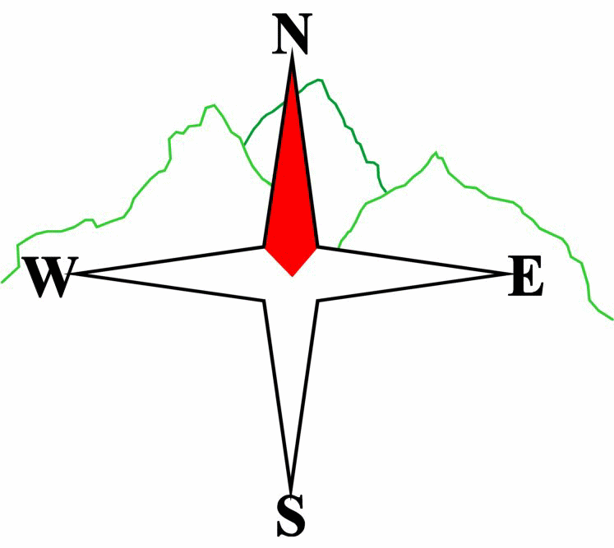***Blairgowrie & District Hillwalking Club***

**www.bdhc.org.uk**

**Black Mount – from Glencoe Mountain Resort**

**20/07/2024**

**O.S. Map No**: 41 & 50

|  |  |  |  |  |
| --- | --- | --- | --- | --- |
| **Bus times:** | **Blairgowrie** (**Wellmeadow**): **08:00** | | **Alyth** (**Square**): **07:45** | |
|  | **Other: TBA** | | | |
|  | | | | |
| A Walk – Meall a Bhuiridh & Creise | | | | |
| Start Glencoe Ski carpark NN 266 525. Take path beneath ski lift S to top of lift. Go W c.600m to bealach 254 517. Climb ridge S to summit of **Meall a Bhuiridh (M 1108m)**. Continue WSW down ridge to narrow bealach. Climb W to top of ridge. Go N c.700m to summit of **Creise (M 1100m)**. Return S but continue on to Clach Leathad (1099). Descend ESE down Sron nam Forsair to WHW at Ba Bridge. Turn N and follow WHW to Blackrock Cottage then S to start. | | | | |
| Approx. distance: 17.5 km | | Total ascent: 1260 m | | Min. **walking** time: 7 hrs |
|  | | | | |
| B Walk – Meall a Bhuiridh | | | | |
| Start Glencoe Ski carpark NN 266 525. Take path beneath ski lift S to top of lift. Go W c.600m to bealach 254 517. Climb ridge S to summit of **Meall a Bhuiridh (M 1108m)**. Descend E then SE over Creag an Fhirich to SW corner of plantation. Follow River Ba E to Ba Bridge. Turn N and follow WHW to Blackrock cottage then S to start. | | | | |
| Approx. distance: 13.5 km | | Total ascent: 800 m | | Min. **walking** time: 4 ¾ hrs |
|  | | | | |
| C Walk – Chairlift and walk to Creag Dhubh | | | | |
|  | | | | |
| Start Glencoe Ski carpark NN 266 525. Take the ski lift up to the top at Eagles Rest. **Please note the charge for this is £17 each.** Proceed on the signposted route to the Glen Etive viewpoint at the summit of Creag Dhubh before returning to the top of the ski lift. Going eastwards take the path that descends gradually to the Old Military Road at 277 514 then take this S to join the WHW at 280 499. Go southwards for c.800m to investigate Ba Cottage then return N to follow WHW to Blackrock Cottage then S to the start. | | | | |
| Approx. distance: 10.9 km | | Total ascent: 130 m | | Min. **walking** time: 4 hrs (@3kph) |

|  |  |
| --- | --- |
| IMPORTANT: YOUR SAFETY IN THE HILLS | |
| **The Committee reminds members and guests of the following important points:** | |
| * You are responsible for your own safety * Club officials are not trained mountain leaders * Are you fit enough to complete your chosen walk in the available time? * Know where you are going on the walk and follow the route on your map. * Know how many are in your party and stay together | * Ensure you have enough food plus emergency rations * Carry a map & compass, survival bag, torch, whistle and small first aid kit. Know how to use them. * In winter conditions you must carry an ice axe on high level walks (club rule). You are also recommended to carry crampons. * **Learn** how to use your equipment. |
|
|
|
|
|  |
| **Club officials will be happy to give advice on any of these points if requested.** | |

## The next club walk is on the 11th August to Bynack More starting at 7.30 am (Blairgowrie) and 7.15 am (Alyth).

Other information/events: 17th August BBQ in Dunkeld. Further details TBA

**Please note that the Minimum walking times are based on reasonably fast walkers and assuming good conditions. The times do not include stops or breaks.**

## **In poor weather conditions or if members are not comfortable walking at 4km/hour then alternative or shorter routes should be considered.**